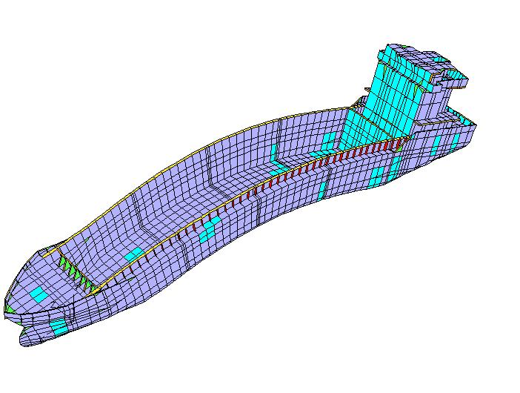 |   ASDEPP  International Workshop on Advanced Ship Design for Pollution Prevention  Split, 23rd and 24th November 2009
REGISTRATION FORM
Name:
(First name, Middle name, SURNAME)
Company/Organisation:
Address:
Telephone:
Fax:
E-mail:
Workshop participation fee includes:  - Technical programme attendance.  - Workshop proceedings.  - Touristic visit to Split with lunch on Sunday, 22nd November.  - Lunches & refreshments on 23rd and 24th November.  - Workshop dinner on 23rd November. |  | € 200

Payment should be made until 7th November by bank transfer:
Account holder’s name: University of Zagreb, Faculty of Mechanical Engineering and Naval Architecture
Bank name and address: Zagrebačka banka d.d., Savska 60, 10000 Zagreb, Croatia
Account number: 2360000-1101346933
SWIFT/BIC Code: ZABAHR2X
IBAN No: HR4723600001101346933
Details of payment: ASDEPP – Participants SURNAME

Please send registration form and a proof of bank transfer until 7th November
to the e-mail silvana@fsb.hr, fax (+385-1-6156-940), or following address:
Silvana Škoko Gavranović

Faculty of Mechanical Engineering and Naval Architecture University of Zagreb
Ivana Lučića 5, 10002 Zagreb, Croatia

